Bulk and Retail Petroleum

Module 9

Inspection Procedure Outlines

January 2021

Uncontrolled copy for training purposes only
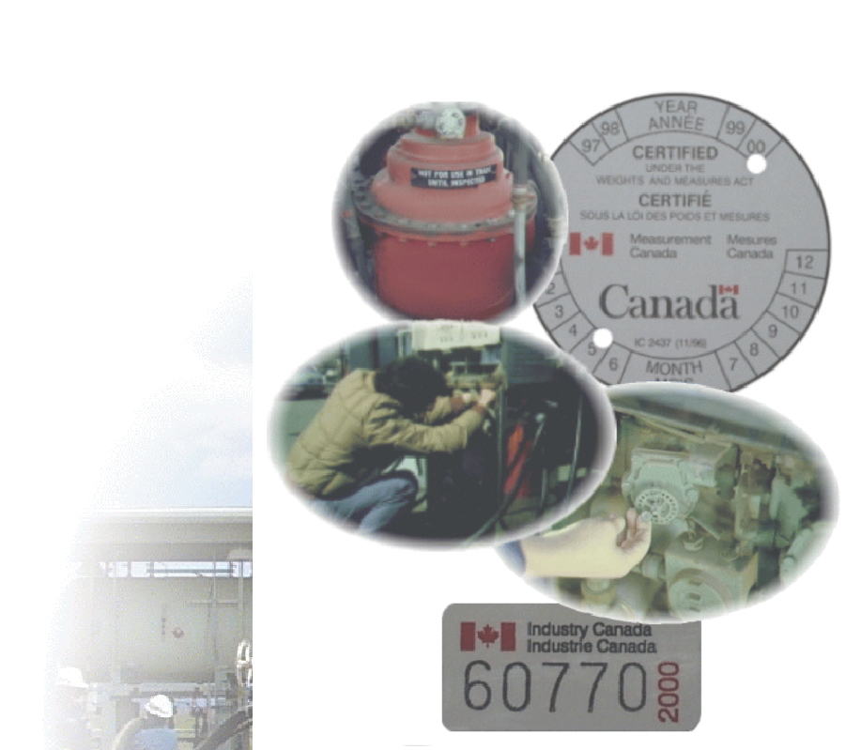
Inspection Procedure Outlines
The Minister ensures that all designated persons are trained and qualified in the same way and that all examinations carried out by these persons are carried out in the same way each time. Uniform application and consistent interpretation of legislation, policies and procedures is key to the effective administration and enforcement of the Weights and Measures Act, Regulations and Ministerial Specifications.

The purpose of the Field Inspection Manual (Inspection Procedure Outlines and Standard Test Procedures) is to provide inspectors and other interested parties with a guide to the inspection of basic volumetric measuring devices and systems. The IPOs outline the minimum tests which must be performed to ensure that basic volumetric measuring devices comply with the legislation. The STPs provide examination criteria for installation and use of devices and describe test procedures.

The use of the IPOs and STPs to evaluate the compliance of a basic volumetric measuring device or system should be considered the norm rather than the exception. In some circumstances, additional tests may be warranted. In cases such as these, the Regional Specialists should be consulted, and care must be taken to ensure that these tests adhere to the intent of the Act, Regulations and Ministerial Specifications for volumetric measuring machines.

REFER TO APPLICABLE INSPECTION PROCEDURE OUTLINES (IPO) IN THE FIELD INSPECTION MANUAL
Type 50, 51: Gasoline/Diesel Fuel Dispensers and Refuellers

Rack-mounted meters, pump supplied

Vehicle-mounted meters, pump supplied

55.10, 55.11: Truck mounted meters, gravity supplied

